# My SQL User Manual

# MySQL Installation

1. Go to the link: <http://dev.mysql.com/downloads/installer>

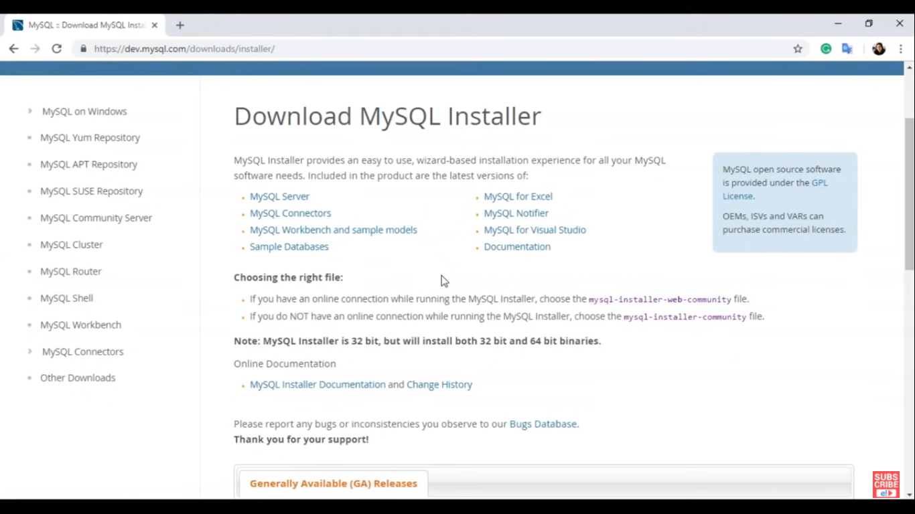

1. Download mysql-installer-web-community

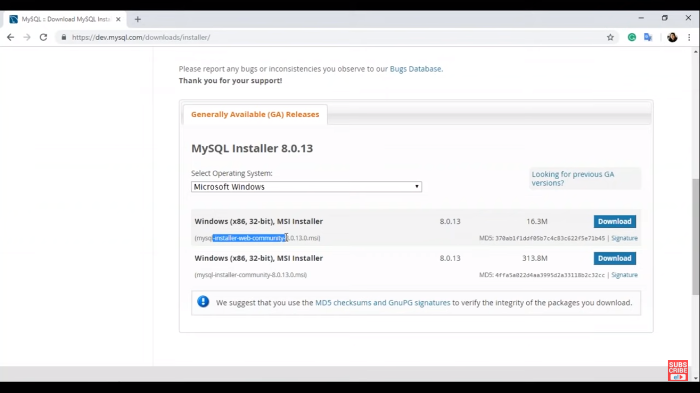

1. On next page, Click No thanks, just start my download

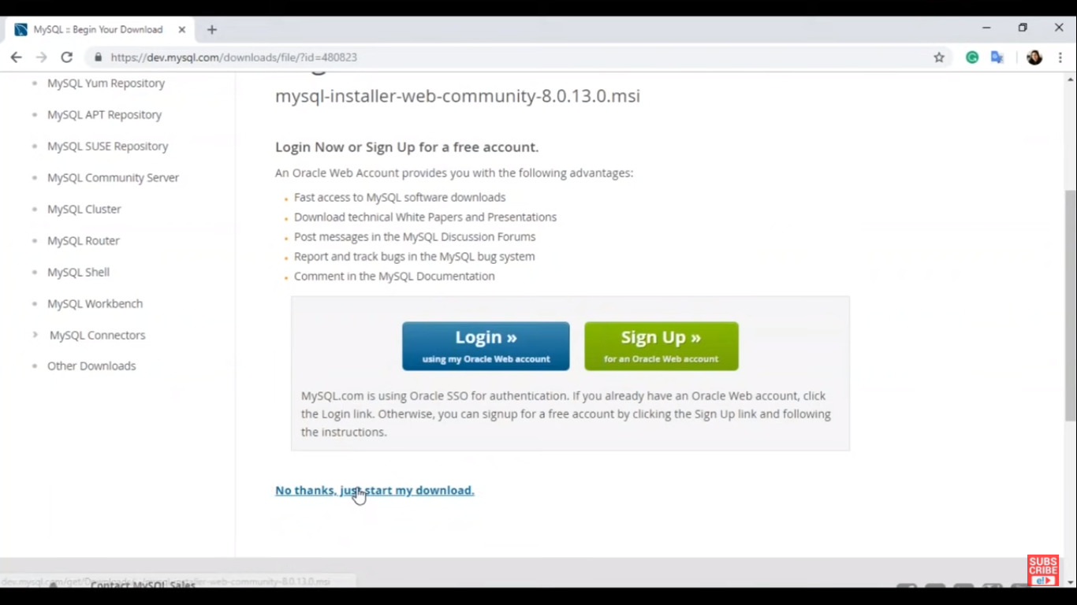

1. Open the downloaded mysql installer

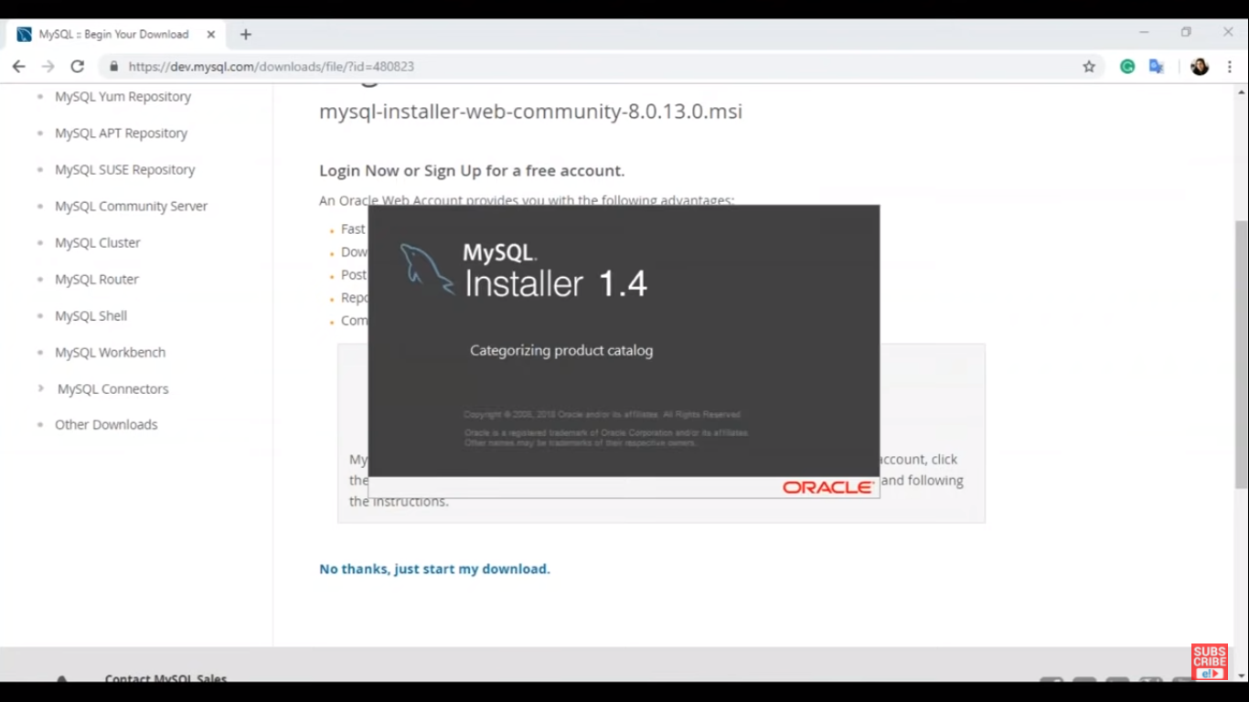

1. Click I accept the license terms -> Next

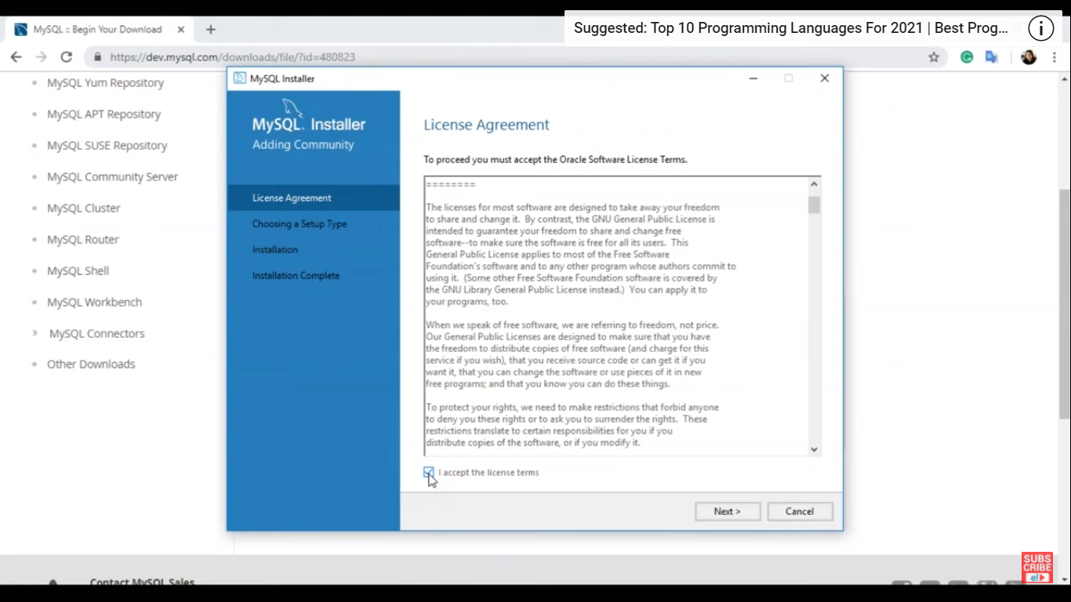

1. Select Developer default -> Next

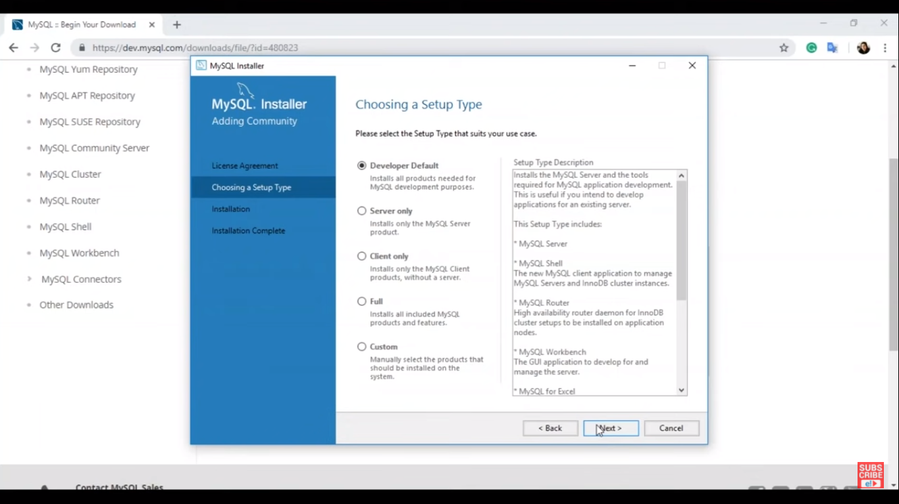

1. Change path as shown -> Next

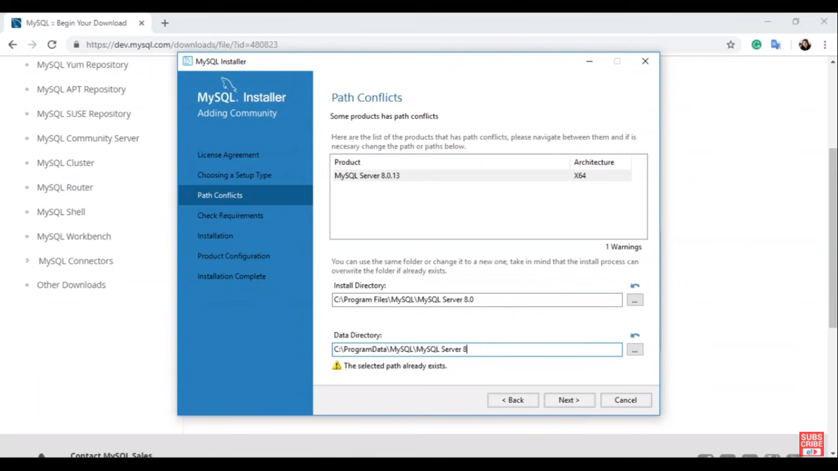

1. Do not select any radio button -> click Next -> click Yes

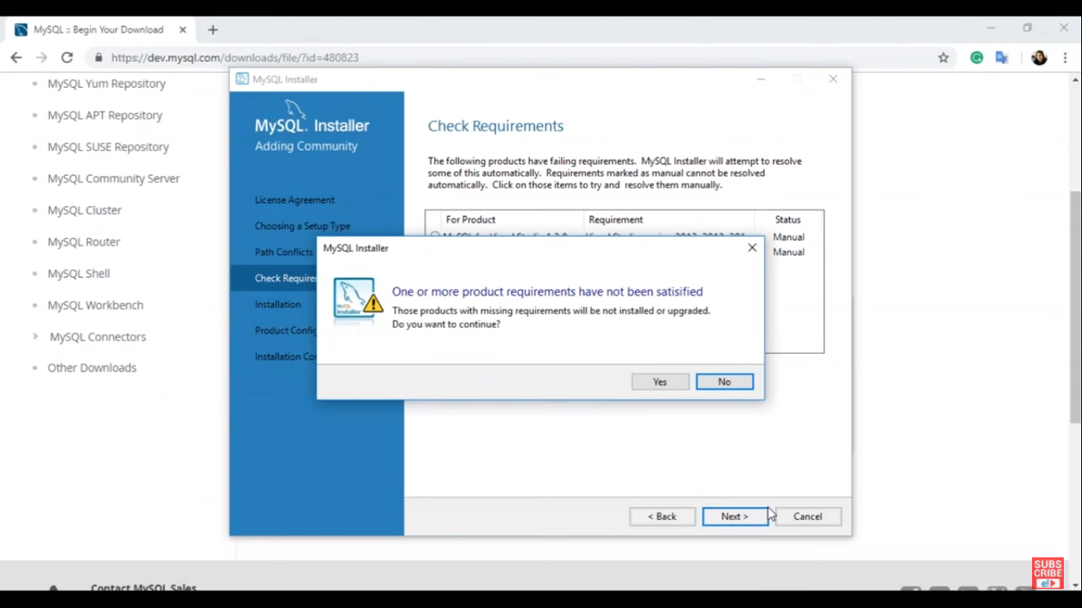

1. Click Execute, Try again if any execution stopped

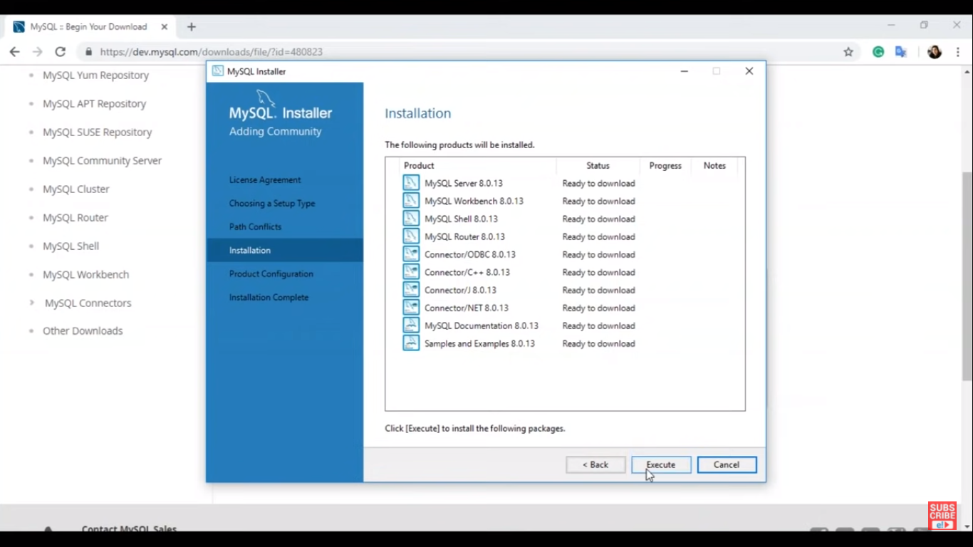

1. Click Next

Choose Standalone mysql server -> click Next

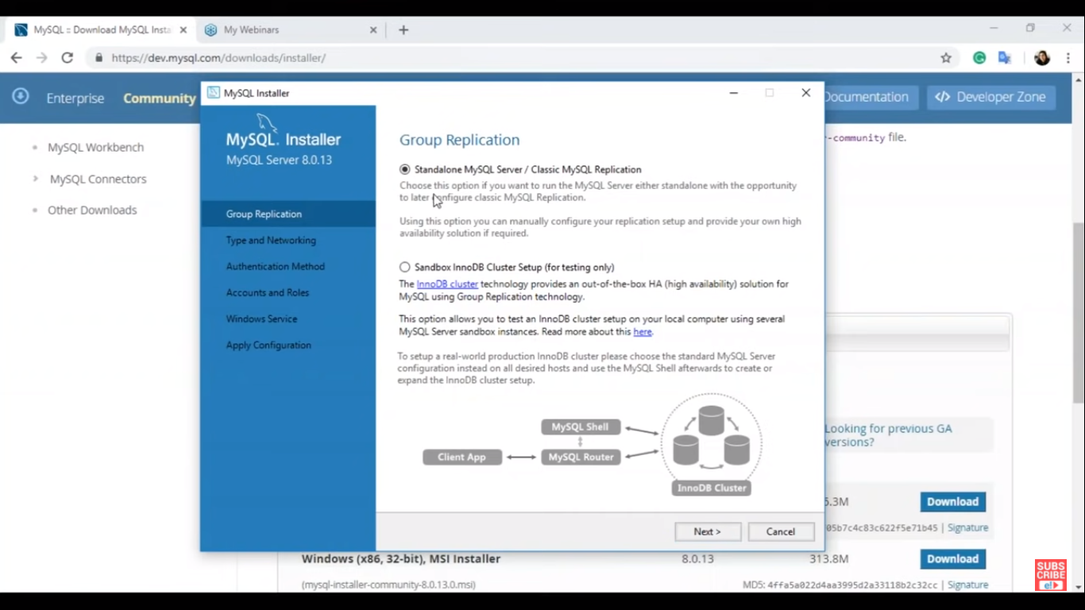

Click Next again -> choose ‘Use Strong Password’ -> click Next -> Give password

1. Do as following -> click Next

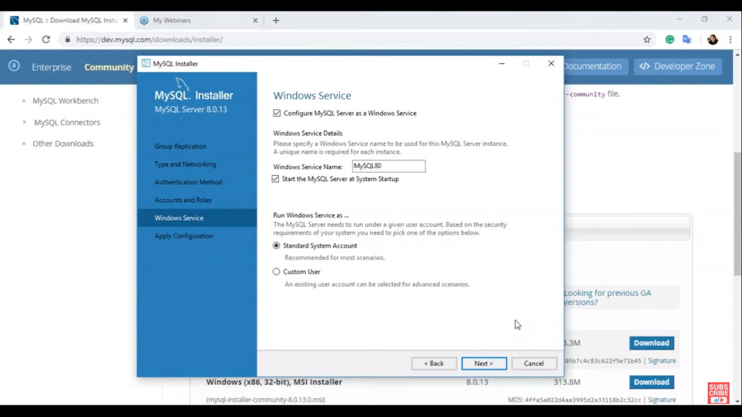

1. Click Execute -> click Finish

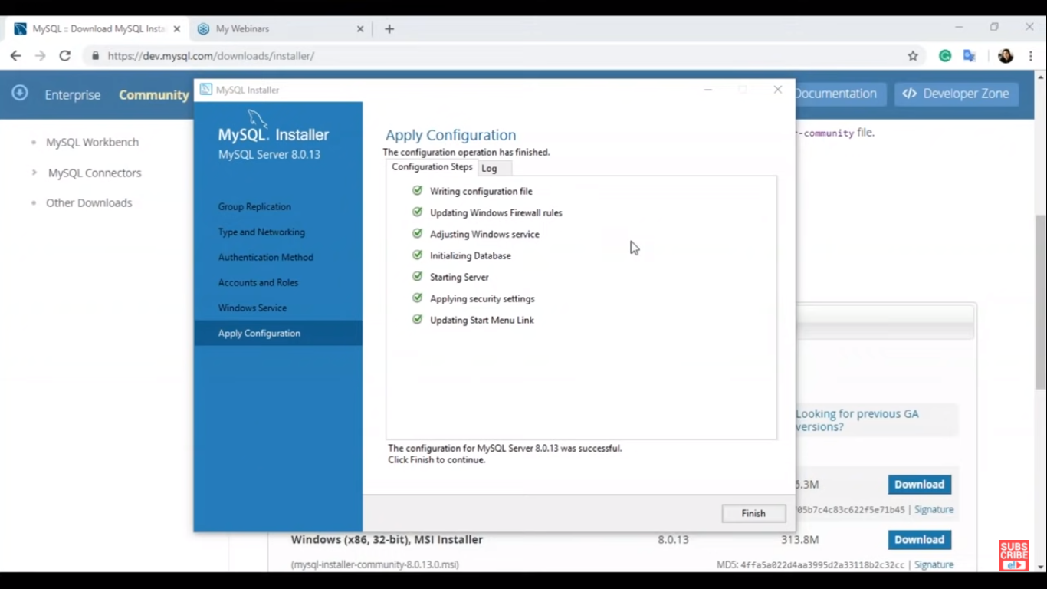

1. Give username and password -> click check -> click Next -> Execute -> Finish -> Next -> Finish

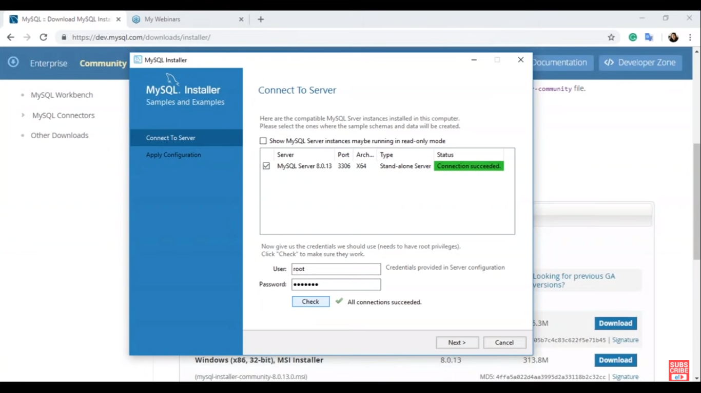

1. To verify the installation: open MySQL Command Line Client and enter password

